Duy Mai, Twan Tran, and Hoang-Uyen Tran

Department of Engineering, Cal State Long Beach University

CECS 450: Data Visualization

Dr. Anthony Giacalone

December 8, 2023

**What is the problem?**

The last decade, our earth has been facing global warming or the greenhouse effect known as climate change. Scientists have diligently documented global surface temperatures using thermometer-based records. This observed consistent rise in temperature is a clear indication of the changing climate. The emission of greenhouse gases (GHGs) such as CO2, CH4, and N2O. These GHGs act as a blanket in the Earth’s atmosphere, trapping heat and causing the temperature rise of Earth. The change in temperature may seem like a good sight for people living in the colder area of Earth because they will be experiencing a warmer winter than their usual cold weather. However, only one gain but many unpleasant situations come along with the temperature warmer such as: destruction in the marine life for species that live in the colder area of water that their habitat got destroyed. Melting of glaciers, rising sea level, extreme weather events, ocean acidification, disruption of ecosystems, and threat to water resources.

*Illustrate of Change in Temperature*

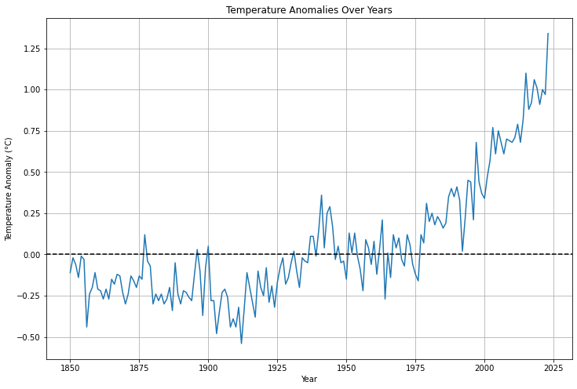

*Illustrate of Disasters*

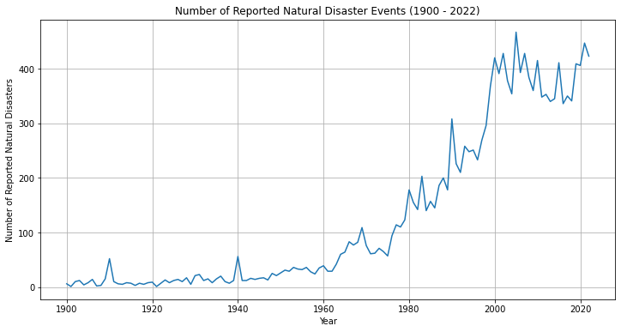

**Data Gather**

Global Carbon Atlas is the climate change resource center: Provides CO2 emissions data by country and industry (Lu, 2023). The article covers worldwide CO2 emissions per capita (metric tons) from 2021 to the future (e.g. 2050,2070). Our World in Data: Offers a wide range of environmental data including CO2 emissions (Ritchie, Roser, and Rosado, 2020). Carbon Brief: Global CO2 emissions could peak as soon as 2023, IEA data reveals (Evans and Viisainen, 2023). IMF: World Needs More Policy Ambition, Private Funds, and Innovation to Meet Climate Goals (Black, Jaumotte, and Ananthakrishan, 2023). Data about global CO2 emissions from fossil fuels, land use change, region, annual emission, per capita per country, emission change over time. Each data has its data record from 1750 to 2022 according to each country saves in a CVS data. Collecting many data, then sorting them into different categories that are similar for comparison. For example, shows a graph to compare each country usage of CO2 emission.

**Utilizing data**

CO2 Emissions by country specific in 2021 China was known as the most populous country in the world. The expectation for the emission level will be at least top 1 or 2, however the result came out unexpected that change initial hypothesis.

*Illustrate Global CO2 Emission by Country in 2021*

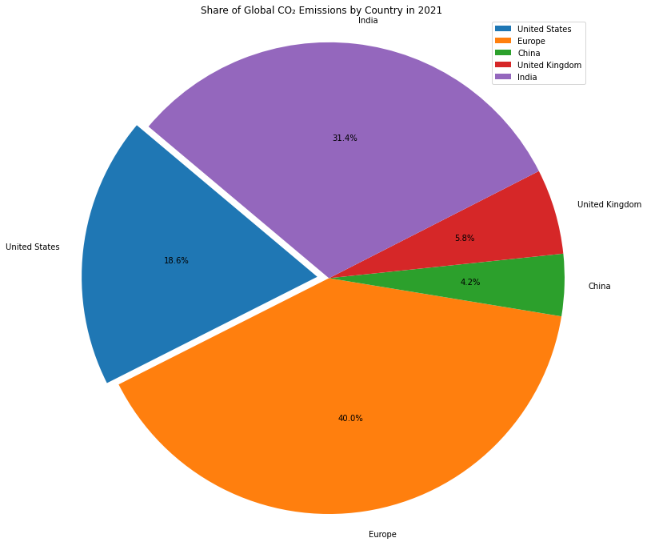

As the chart diagram shows that Europe is the country consumes the most CO2 Emission. European styles are vintage and still in the monarchy, so even the world is technologies development, but they keep most of their routine as back in the day such as: wood fireplace, fashion industry, appliances use. China having over 1.4 billion people, however for the last couple decade, China drastically develop from transportation, appliances use, and majority of their daily routine to technology and their goal is to fast and efficient. This change help decrease the bad breathing air in China. Untied State is the strongest country in development and technology, but only 18% of all the top nations. Fast development shows that all the countries with drastic development try to decrease everything that will damage the environment. Commonly used are bar graphs or line graphs but choosing the right graph to display the specific information that will catch the viewer also be the important task. Pie chart is the best way to display one problem but compare between other factors such as a share of global CO2 emissions in this example. The color distinct each country and with the impact of color make the user can just roughly know how much each country consume CO2 just by the color without looking at the percentage number.

*Illustrate The Effect of the environment from warming climate.*

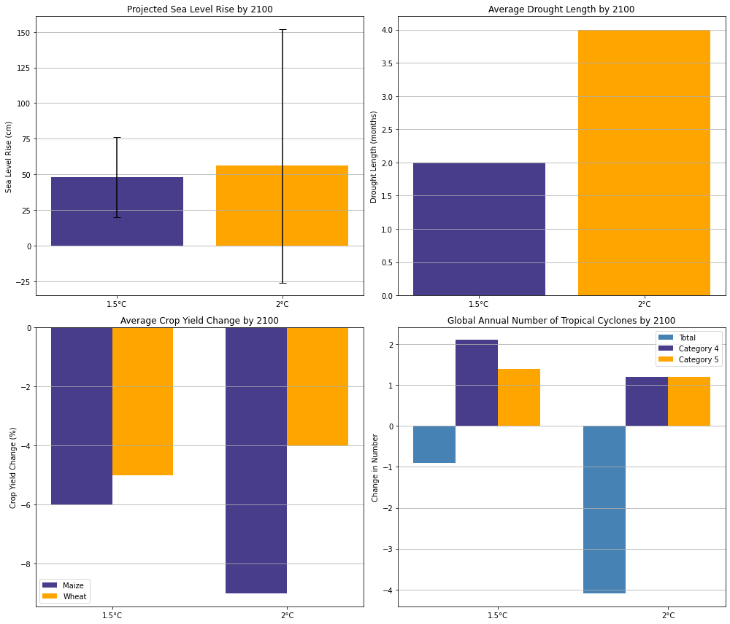

Sea level has been rising 0.5 Celsius with the water level rising may cause some of the countries that have a close surface to the sea level to disappear in the future. The plot graph inside the normal graph and this combination provides a friendly visual and can see the average of the sea level can rise. Drought is increasing significantly because the warmer climate causes the water to emit causing water shortage in some countries. Crop yield shows that the warmer climate favors the stock that likes to growth in warm weather. Increase in 0.5 Celsius shows that maize (corn), likely grown in warm weather so the change in temperature is a huge advantage for corn. However, on the other hand wheat is not having the best result. With the temperature change some of the crops (food item) might go extinct. Using different colors instead of using same color but different shades help viewer to identify faster. Also, easy to make a comparison and come up to the final solution.

*Illustration of Disaster Over Years*

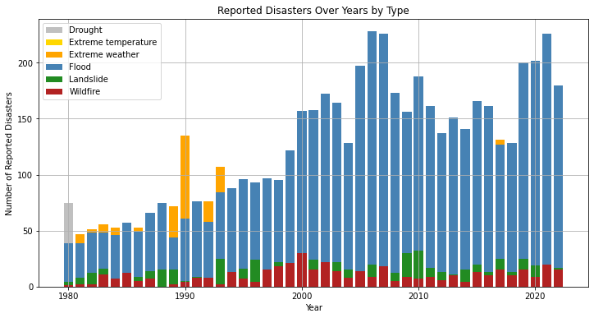

80% of our Earth is covered by water so when global warming causes glaciers to melt causing a rise in sea level, then water evaporates causing drought, then follow that is increase in flood. Flood increase almost 50% compared to other disaster this mean our glaciers are melting at a fasting rate just in couple decade. As for the visual of the graph, it captures all the key details with a key box and clear distinct color indicates different disasters. Overall, the graph delivers to the viewer an easy-to-understand message it wants to deliver. Color makes a big impact on the delivery to viewer because people’s eye understand color before understanding word. Stacking all the disasters over each other can give a sense of comparison for viewer to easily know which disaster happen more within the year or compare which disaster likely to occur over time.

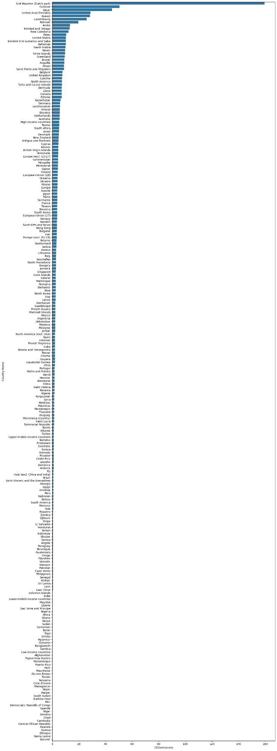

The data is a summary of all the countries in the world about CO2 Emission. This is the unclean data that we created by importing all the CVS files data and create the graph using Python, this is the unclean data. As a visual class, this graph does not deliver the main idea toward the user when they investigate the graph. Confused will be the first thought and visible (can’t see) will be the second thought. Color will be the biggest impact because it all the same color to represent the CO2 release from each country, there are no main highlight color that indicate which it the country that release in median size. No title will be harder for viewer to analysis what the main idea this graph delivery.

**References**

Ritchie, H., & Roser, M. (2020). *CO2 emissions*. Our World in Data. <https://ourworldindata.org/co2-emissions>

*World Needs More Policy Ambition, Private Funds, and Innovation to Meet Climate Goals*. (2023, November 27). IMF. <https://www.imf.org/en/Blogs/Articles/2023/11/27/world-needs-more-policy-ambition-private-funds-and-innovation-to-meet-climate-goals>

Staff, C. B. (2023, October 26). *Analysis: Global CO2 emissions could peak as soon as 2023, IEA data reveals*. Carbon Brief. <https://www.carbonbrief.org/analysis-global-co2-emissions-could-peak-as-soon-as-2023-iea-data-reveals/>

‌

‌

‌